38.49: a) To find the maximum in the Planck distribution:
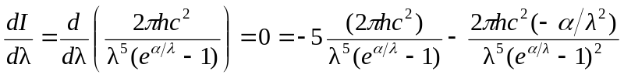
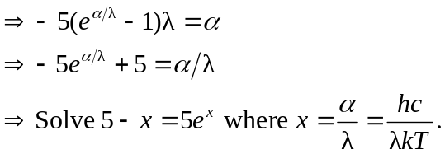
Its root is 4.965, so 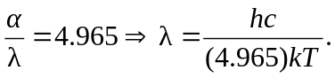
b) 